User Manual

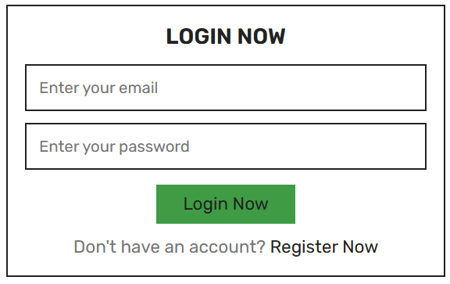

For the log in form, input your credentials if you already have an account.

But if you don’t have an account, just click Register Now

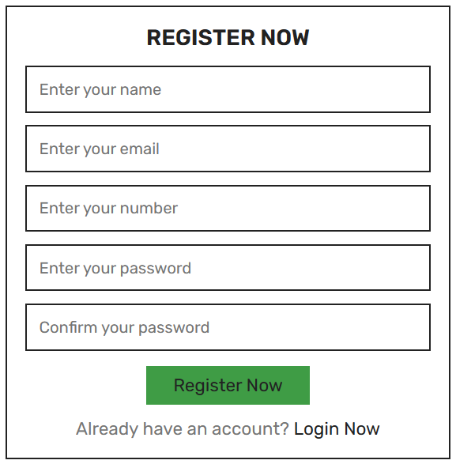

In register form, input the necessary info and register.

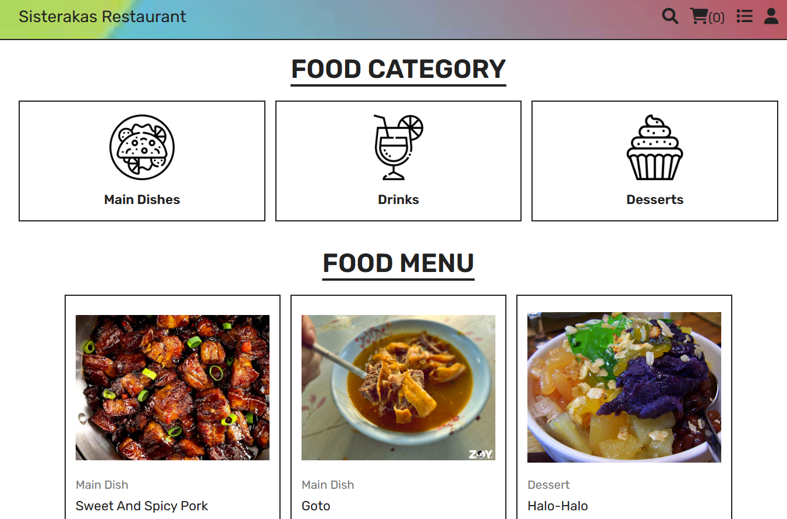

Once you’re logged in. You will see the home menu which includes the category and the food menu. The top right panel has search function, your cart, your order lists, and your user account.

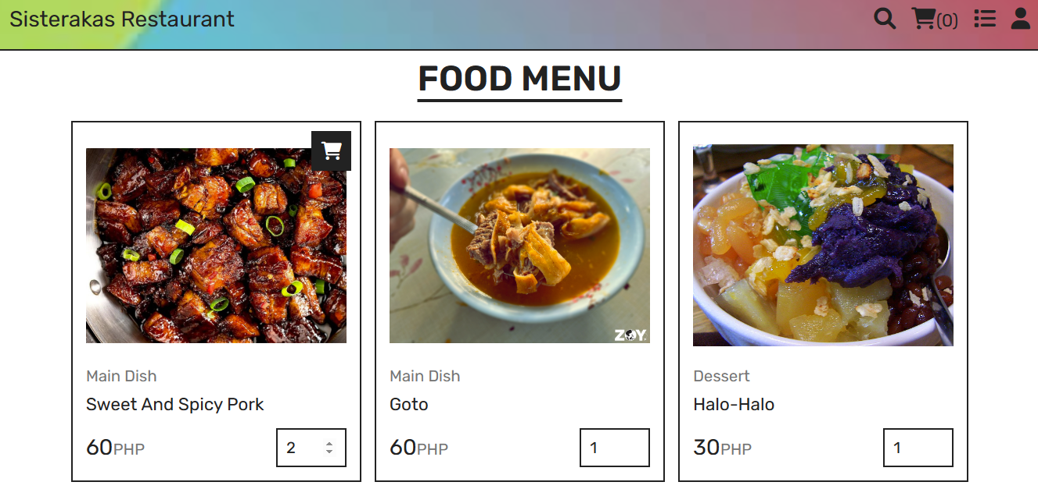

Choose the food you want to add to your cart, just hover your mouse to it and the click on the cart to add it in your cart. Once your done picking the food you want, click the cart at the top right panel.

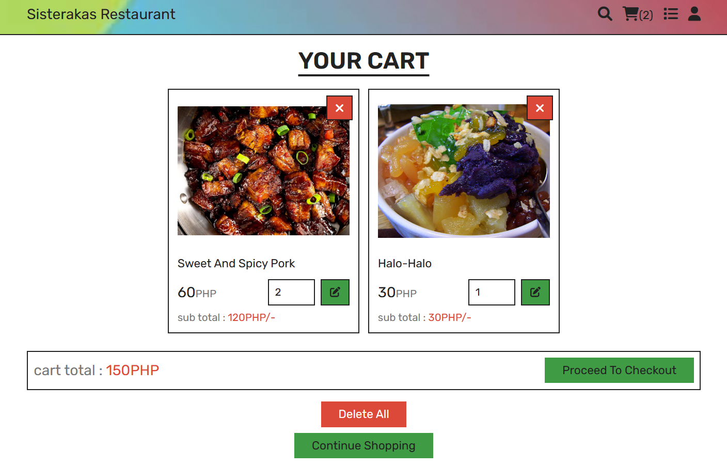

After clicking the cart, it will lead you here where you can either remove a product or update its quantity. Then you can continue shopping if you still want to add more into your cart and if there’s nothing else you want to change, click proceed to checkout.

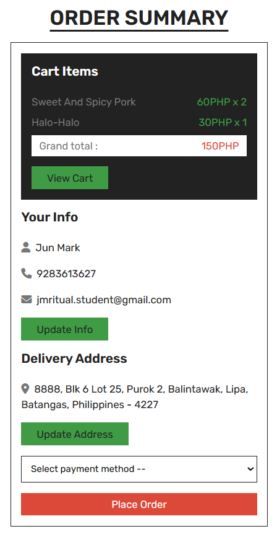

Here you can see the total price of your cart and update your info. After that Select payment method, then proceed to click Place Order.

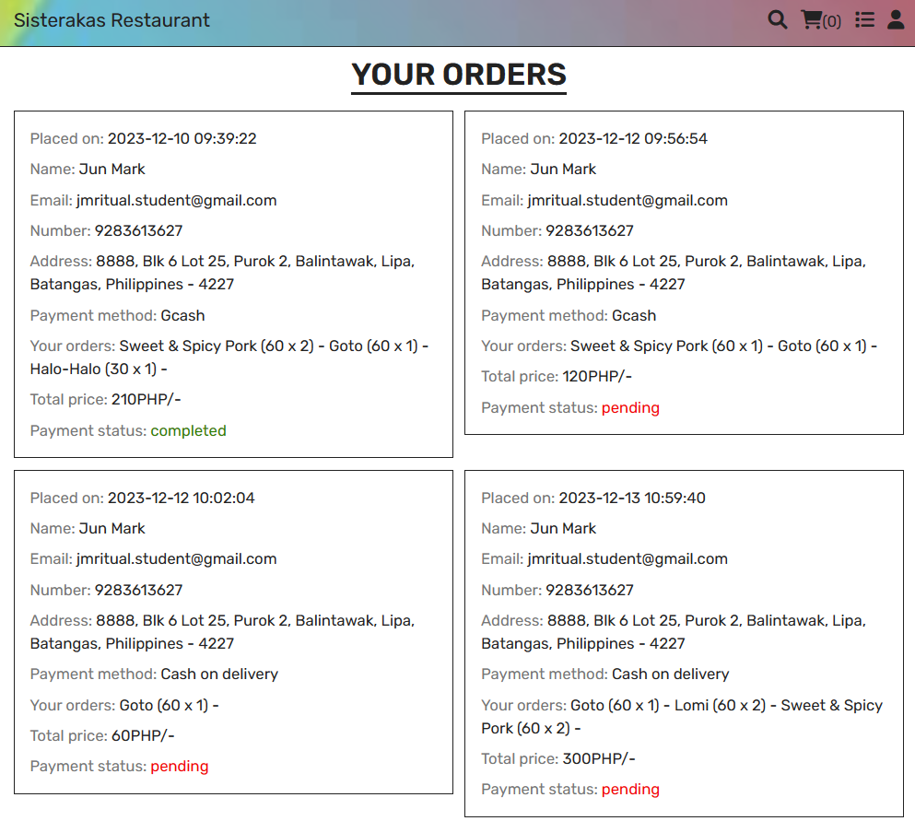

By clicking the order lists beside the user at the top right panel. It will lead you here where you can see all your existing orders. Once the transaction is done, the payment status will change into completed.

Admin Manual

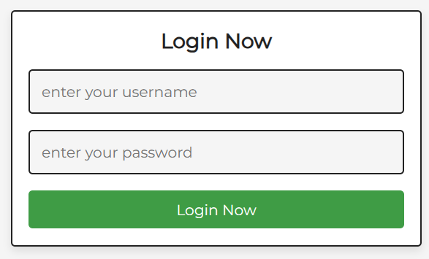

The default username is admin and password is 111. After you input those, click log in.

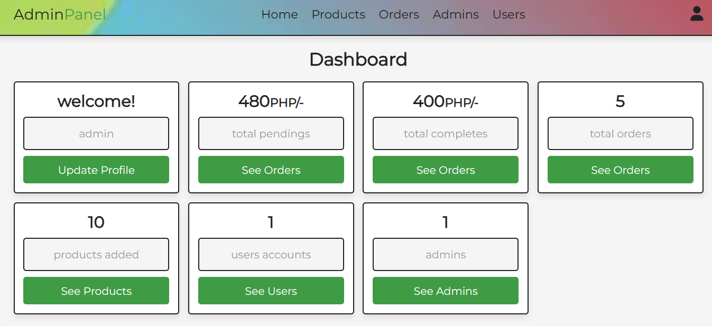

After logging in, it will lead you to the dashboard where you can see all the info about your website.

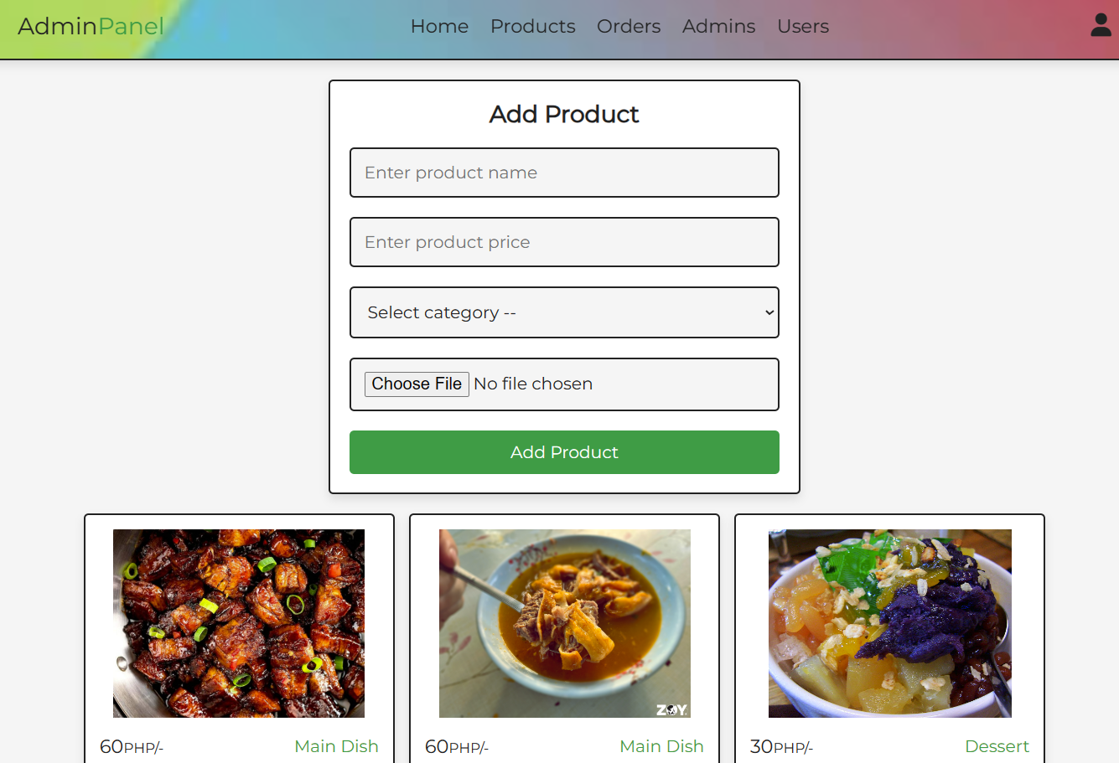

When you click the Products at the top panel, it will lead you here where you can Add Product. Input the necessary info about the product and choose an image to attach to it then click Add Product.

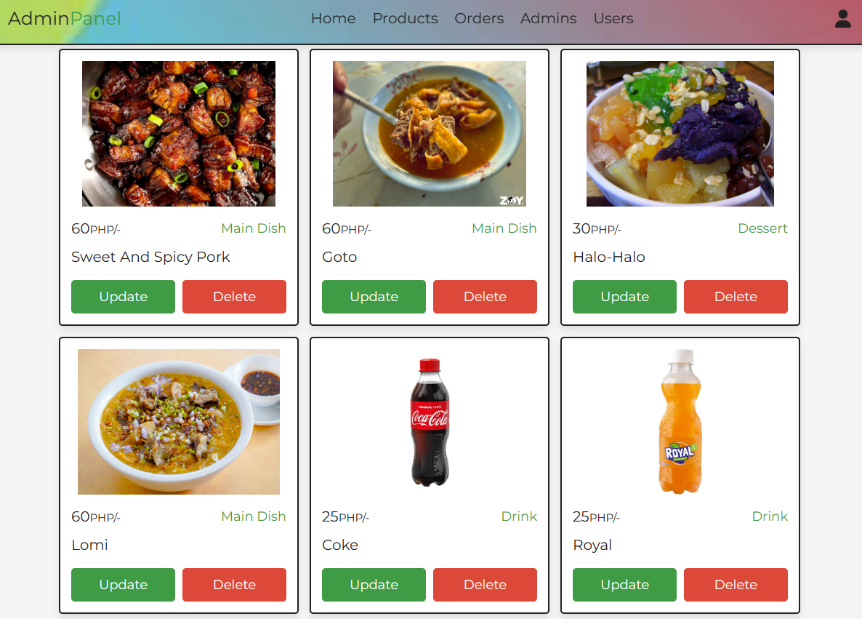

Scroll down a bit and you will see here all the existing product in your website. You can either Delete them or Update the info.

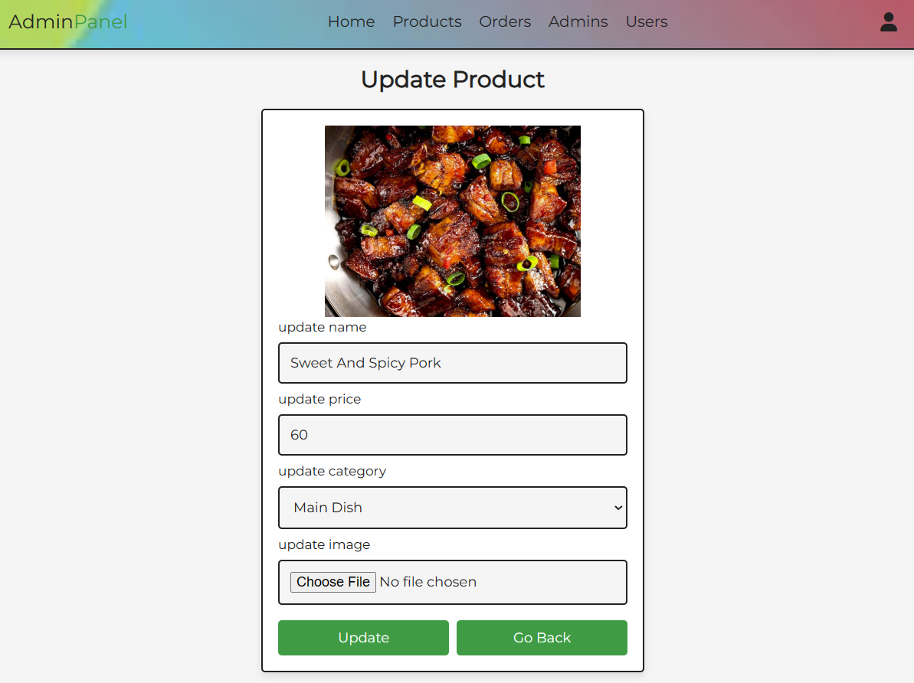

If you click update to a product, it will lead you to the update product form where you can change its info and even change the image. Click Update once your done.

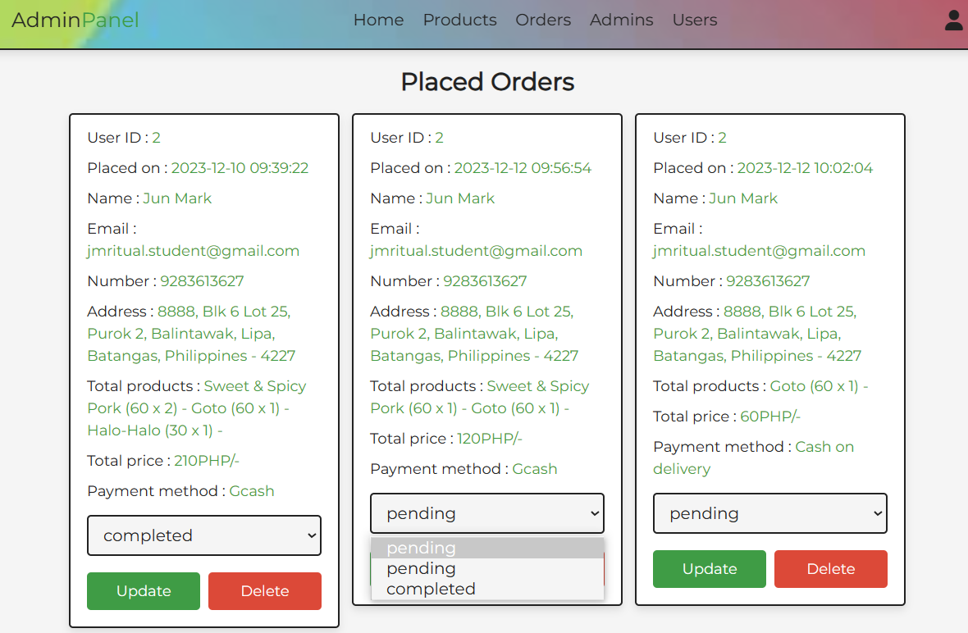

To get here click the Orders at the top panel. It shows all the existing orders that is placed by the users. You can update or delete their orders. When updating just click the drop down menu and select, then don’t forget to click Update afterwards.

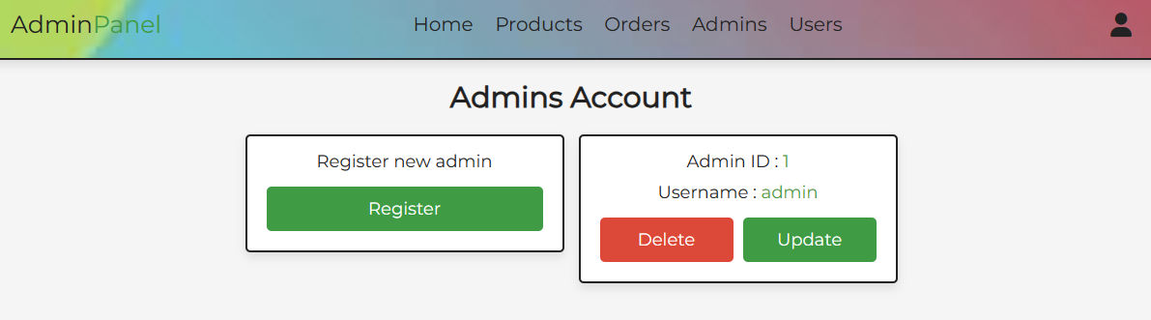

If you click the Admins at the top panel, it will lead you here where you can see all the existing admin accounts and you can also delete or update it, plus you can also register a new one.

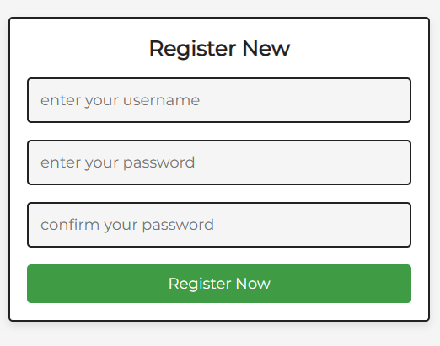

If you want to register a new admin, input the necessary info and click Register Now.

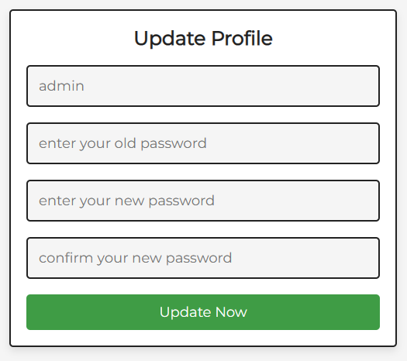

This is the update admin form where you can change username and password.

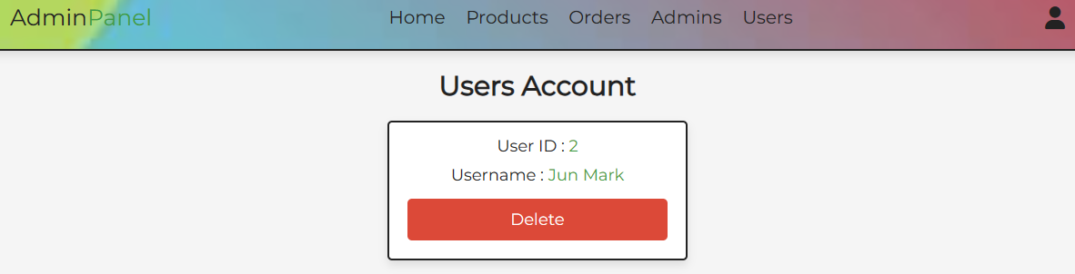

Lastly, click the Users at top panel to get here. It shows here all the existing users and you have the authority to delete their account when you need to.